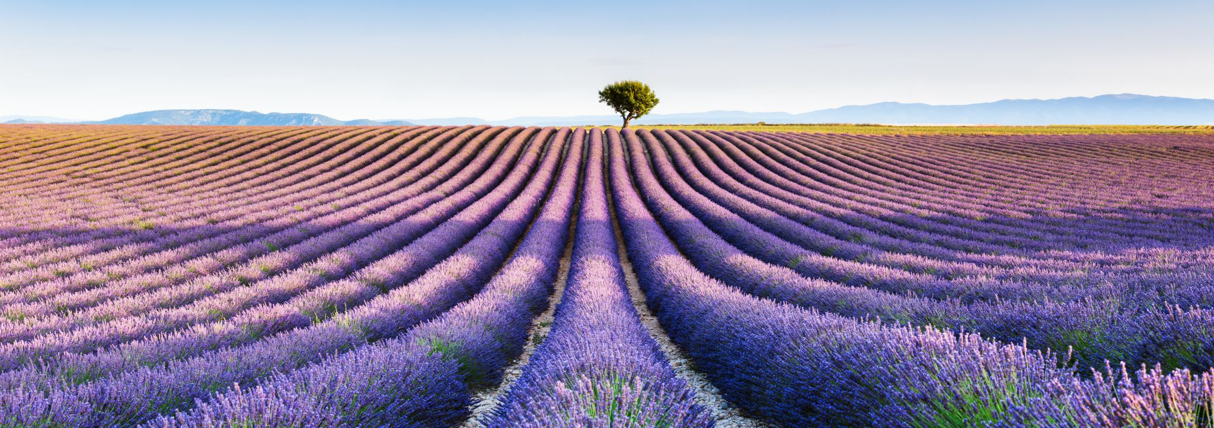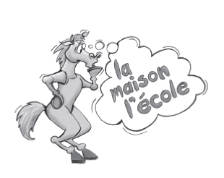
Dr. Eric Jackman Institute of Child Study Laboratory School Junior French Curriculum
Christel Durand
Curriculum Night 2023

We started the year in the French class, we are all doing our very best and it has been an amazing and strong start of the year!
We continue to use the AIM method (Accelerative Integrated Method of Language Learning) as part of our program. It is a sequential program designed to accelerate the acquisition of French as a second language.
The program is based on stories rather than themes. It is highly communicative, and the primary goal is the development of oral and written comprehension skills among the students.
In order to facilitate authentic learning, we are striving to create a classroom environment where both the teachers and the students communicate in French in the context of their learning experience.

The students will develop linguistic competence through continuous vocabulary building using high frequency vocabulary. The students are introduced to vocabulary that is essential for language acquisition. They will learn to describe, ask questions, retell, extend, and create stories.
During transitions, we are using mindfulness in French with the children. The focus will be learning French through games, and routines.
As we are all aware, mindfulness practices promote space for self-regulation and concentration.
Our program has been developed for the productive use of both oral and written language and integrates games, drama, films and movement.

Grades 3 and 4
The children will have French four times a week, (three times in half groups, and once as a whole class) for a total of two hours and thirty minutes per week. The children will follow basic classroom instructions, and will ask questions using "est-ce-que", "comment", "où", and "qui". They will also use visual cues to understand what they hear.
As the year progresses, the students will read and respond to written material.
They will write responses to written questions, using appropriate vocabulary with correct spelling. They will also be introduced to high frequency verbs, pronouns, plural nouns, prepositions of place, articles with nouns, feminine and masculine, as well as many verbs and expressions.
Both groups will give an oral presentation of five to ten sentences, as well as story retelling, both orally and in written form. Emotions, weather and numbers are all part of the daily routine and interactive games and French films are part of our monthly routine.
The Grade threes and fours are doing a weekly ongoing journal with questions and answers about their French film. Through the journal writing, the students will continue to develop oral and written comprehension skills as well as sentence construction and spelling.
Grades 5 and 6
Grades 5 and 6 have French four times a week, (once in a whole group and three times in half groups) for a total of two hours and thirty minutes per week. The children will follow classroom instructions and interact orally in French. They will learn to respond to oral text using complete sentences.
The students will read and respond to written material, using appropriate vocabulary with correct spelling. The students will give one or two oral presentations using Drama of ten sentences or more. As the year progresses, they will be using more verbs in the present tense and some in past tense.
They will also be using expressions with “être and avoir”, present tense of “ER” verbs as well as faire and aller. Imperative forms, common adverbs, and possessive adjectives. They will build upon their knowledge of pronouns, plural nouns, prepositions of place, articles with nouns, and feminine and masculine. Students will learn how to do story extension, both oral and written.
They also have a weekly ongoing journal with questions and answers about their French film with the opportunity to create their own questions. Our routines include the date, practice and review of vocabulary and interactive activities.
I am so happy to be teaching your children this year. I hope to make their French learning a “magnifique” experience! If you would like to contact me, please email me at christel.durand@utoronto.ca
Merci Beaucoup, Christel Durand

